BRONZE



Bronze Duke of Edinburgh Final Expedition 22/05/2017

Dear Parent/Carer,

I am writing to inform you of the final expedition for the Bronze DofE taking place on 17th – 18th June 2017.
For the starting times please read the information below. The walk will take place in the Sherwood Forest area, details are found below:
- All groups are responsible for getting to start points and being collected from finish locations.
- The main mobile number for the day is: 07900000000 (please ensure your son/daughter has this in their phone)
- Use OS map Explorer 270, or go to http://gridreferencefinder.com/ and enter the following grid reference numbers for the location to get directions. Bear in mind 6 figure grid references are only accurate to 100 metres!

17th June drop off point:
Lawn Covert, Layby off the old Lound Hall colliery access road
DN22 8DF (this will only get you near to the drop off point)
SK 694 736
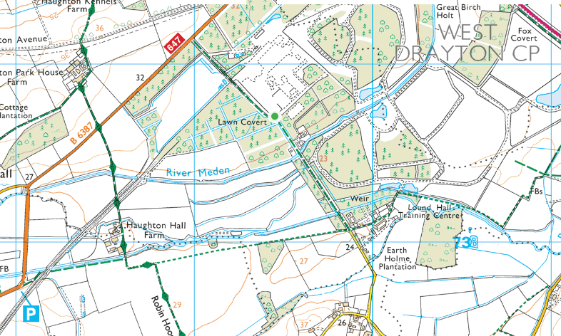

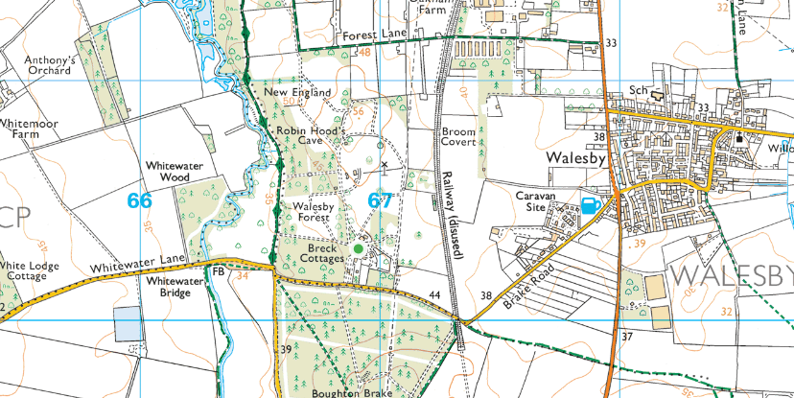
17th June camping location:
Walesby Scout Camp
NG22 9NG
SK 669 702

18th June pick up location:
Vicars Water Rear Car Park
NG21 9AA (This will only get you close to the pick up point)
SK 595 629

PLEASE NOTE: ETA times for each group are ESTIMATED, and shall depend on a number of variables that each group are responsible for.

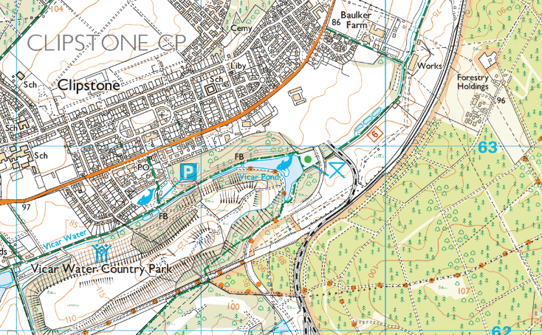

An itinerary for the days is as follows:
- 17th June
- Staggered start for groups. Please arrive 15 minutes before your depart time as each group will need to sign in and check kit.
- 0915 – Group 1 departs
- 0925 – Group 2 departs
- 0935 – Group 3 departs
- 0945 – Group 4 departs
- 0955 – Group 5 departs
- 1005 – Group 6 departs
- 1015 – Group 7 departs
- 1025 – Group 8 departs
- 1035 – Group 9 departs
- All groups head to Walesby Scout Camp (10-15km hike), lunch on route. ETA at Walesby Scout Camp 1600-1800 for all groups to set up camp and cook.
- 18th June
- Staggered start for groups.
- 0850 – Group 6 departs, ETA for collection 1450
- 0900 – Group 1 departs, ETA for collection 1500
- 0910 – Group 9 departs, ETA for collection 1510
- 0940 – Group 5 departs, ETA for collection 1540
- 0950 – Group 7 departs, ETA for collection 1550
- 1000 – Group 3 departs, ETA for collection 1600
- 1010 – Group 8 departs, ETA for collection 1610
- 1010 – Group 2 departs, ETA for collection 1610
- 1030 – Group 4 departs, ETA for collection 1630
- All groups head to Vicars Water Car Park (10-16km hike), lunch on route. Please note that the ETA for collection is an estimate at the pupils walking 3km hour from the distance they have stated on their route cards and stopping for breaks, this can obviously vary depending upon how the groups do on the day.

Pupils will need to bring the following (remember to also check the DofE recommended kit guide):
- Tents
- Sleeping bag
- Roll mat
- Wash kit (for pots and themselves!)
- Trangia’s
- Emergency whistle
- Survival bag
- 4 man emergency shelter (1 per team)
- Team rain cover
- First aid kit
- Torch
- Rucksack
- Waterproofs
- Walking boots
- Bin liner for rubbish
- A container for plenty of water each day
- Food for Saturday and Sunday (packed lunch, meals to cook and snacks)

Please ensure that you check the weather forecast beforehand and if needed pack additional items (sun cream, extra hat/gloves etc). I recommend www.yr.no for an accurate forecast. I must stress that pupils take enough water with them; there will be water available at checkpoints, however sections of the walk can be long before they reach a checkpoint. Also whilst at camp, there will be opportunity for down time so pupils could bring items for this.

Should you require any further information then please do not hesitate to contact Mr Crowley-Volpato (Mr C-V), Staff 2, Staff 3 or Staff 4 at the following email addresses:
info@expededucation.org (Duke of Edinburgh Centre Manager)
info@expededucation.org (Duke of Edinburgh Leader)
info@expededucation.org (Duke of Edinburgh Leader)
info@expededucation.org (Duke of Edinburgh Leader)

